Contents
Expense Codes Background 1
View existing Expense Codes 1
Create new Expense Codes 2
Data Talk 2
To add a DATA TALK mapped code value 5
Re-run the GL 6

Expense Codes Background
Expense Codes are used to summarise transactions into groups of expenses/costs and liabilities, so they can be posted GL in the form of Debits and Credits. The following points should be taken into consideration regarding Expense Codes:
An Expense Code is not associated with an employee. Its possible to have a different expense Code for every element of pay an employee receives.
Expense Codes are used in conjunction with the Cost Centres, i.e. one Expense Code may be used in many different Cost Centres.
The Expense Code is normally derived based on the type of employee and the type of pat that the employee receives.
An Expense Code is an 8-digit number field. Data mapping can be used to ensure the Expense Code output by PeopleXD matches the Expense Code in the Financial Management System (FMS).
The requirement for a new Expense Code would ordinarily be made via the Payroll Operations Manager and usually combined with a new Pay Code/Allowance request. The Expense Code once setup would be added to the Pay Code on the third tab titled General Ledger and should only be input if provided by Payroll, otherwise left blank. For further information about Pay Codes refer to the “How To Manage Pay Codes in the Portal” guidance at P:\PROJECTS\HRIS Programme\12. Support\Reference Data\How to guides.

View existing Expense Codes
To view existing Expense Codes, navigate via:
People Management > Data Centre > Reference Data > Expense Codes
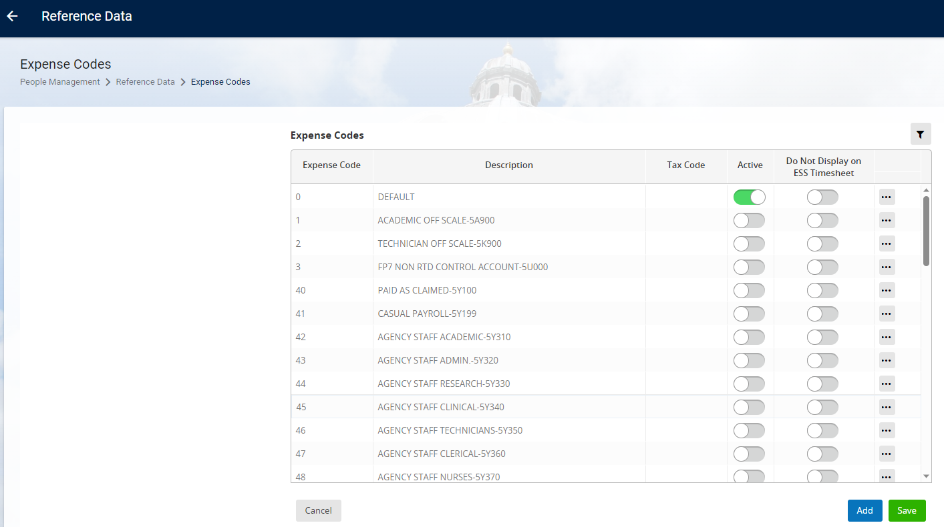

Create new Expense Codes
Expense Codes are not interfaced into PeopleXD from the FMS so there is a requirement to manually create new codes when requested by the Payroll Operations Manager
Navigate to People Management > Data Centre > Reference Data > Expense Codes
The Expense Codes screen opens:
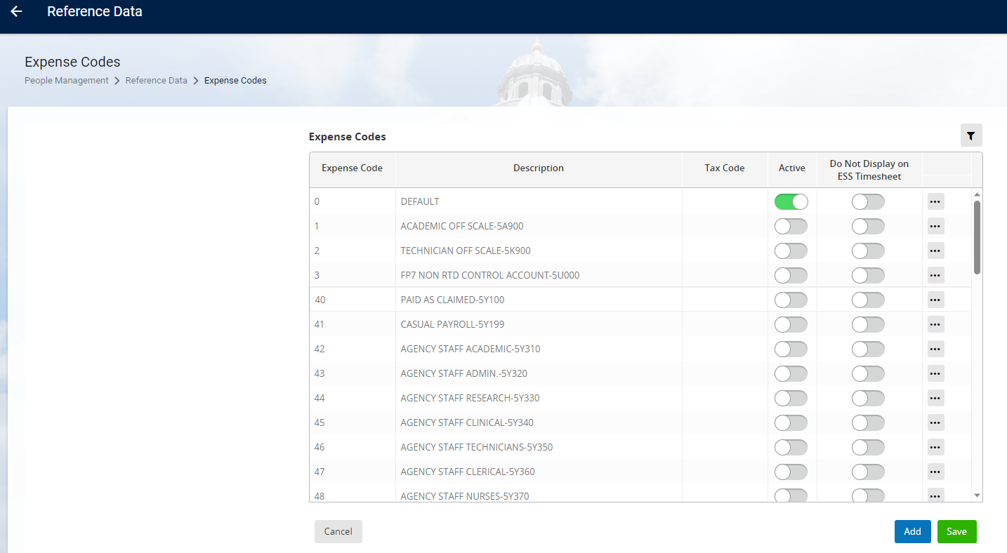
To add a new Expense Code, click on Add.
Enter the Expense Code - This will be the new Expense Code provided by Payroll.
Enter a Description for the Expense Code as provided by Payroll.
Ensure the Active indicator updates automatically.
Click Save.
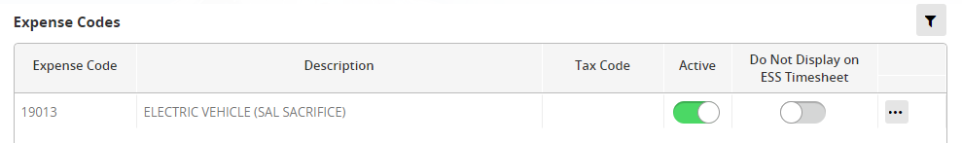

Expense Codes can also be created via the Payroll Dashboard in the same way, navigating to Payroll Dashboard > Settings > General Ledger Costing > Expense GL Codes

Data Talk
Mapped values may be added to the Journal File definition. This is used when the Reference Data item within the FMS does not match the Reference Data item within PeopleXD. An example of this is where the GL/Account codes in the FMS are alphanumeric, whereas the expense Codes in PeopleXD are numeric.
The below steps are used to map elements from the Journal File for output to the FMS.
Navigate to Payroll Dashboard > Settings > General Ledger Costings > General Rules & Settings
The Maintain GL Parameters screen opens.
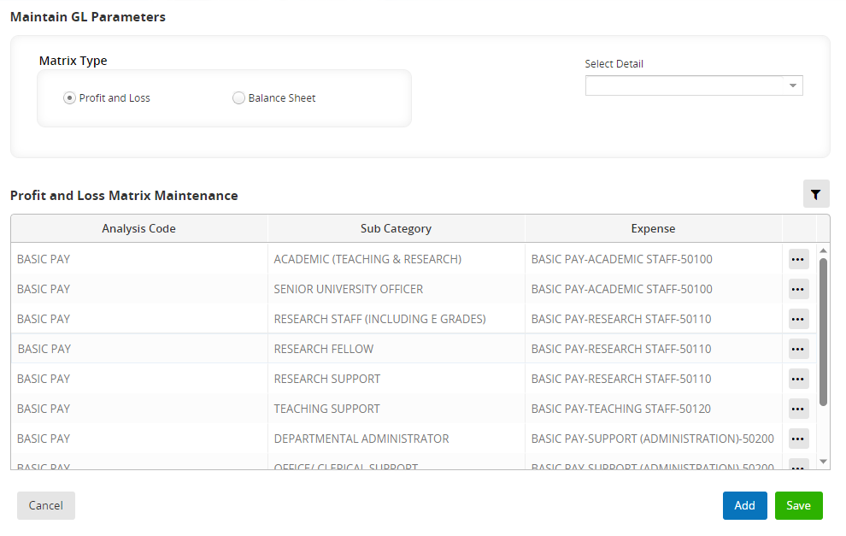
In the Select Detail dropdown menu, select Data Talk
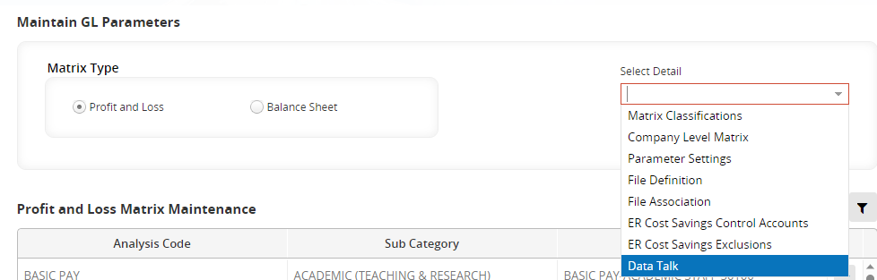

The Data Mapping screen opens:
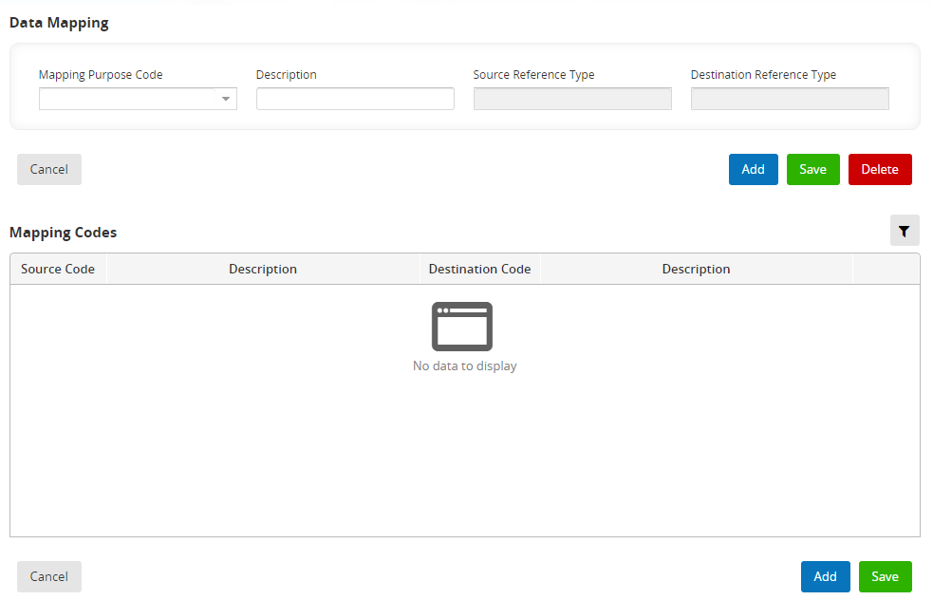
Select the Mapping Purpose Code. In this instance it will be ORAEXP – Mapping of Expense Codes to Oracle Exps.
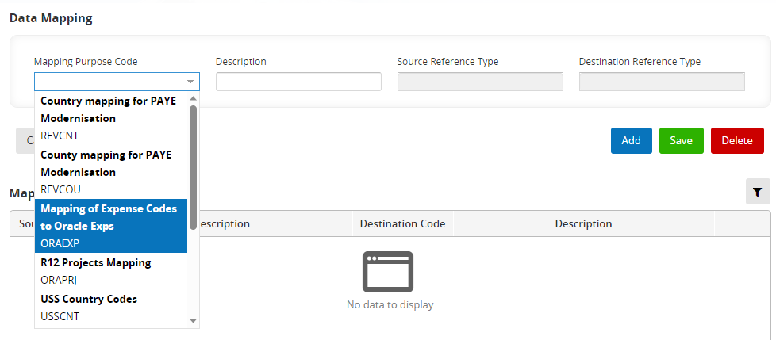
To add a new expense Code for mapping click on the Add.
Enter the Source Code – This will be the new Expense Code provided by Payroll and setup already as escribed previously.
The Expense Code description auto populates.
Enter a destination Code –
Destination Description auto populates.
Click Save.
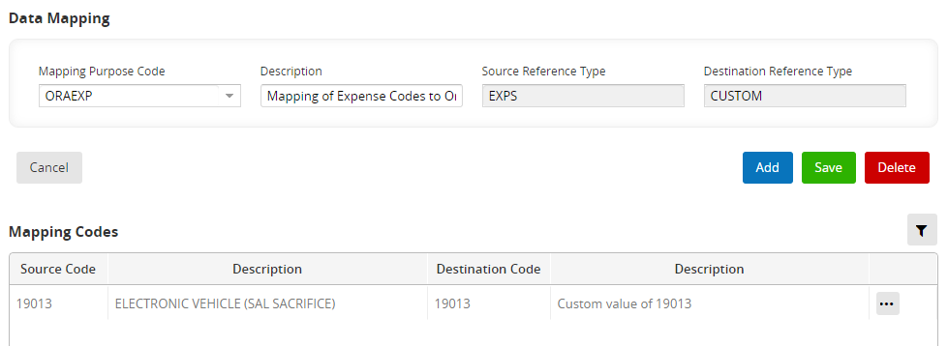

To add a DATA TALK mapped code value
This aspect is already in place so shouldn’t need to be updated when creating a new Expense Code.
Navigate Payroll Dashboard > Settings > General Ledger Costing > Create File Definitions
The Create File Definitions screen will open:
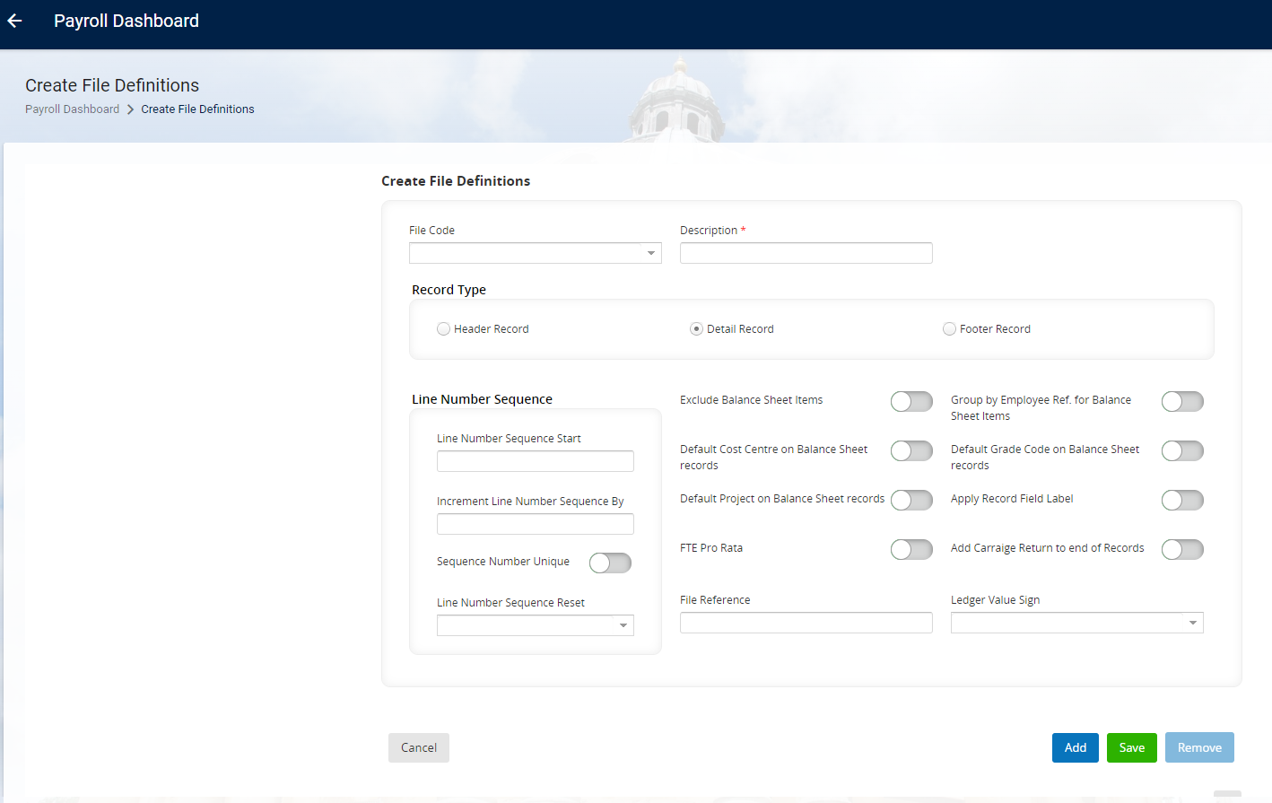
Select the File Type R12GL
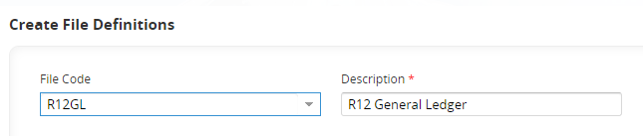
Scroll down to the bottom table and select the row Expense
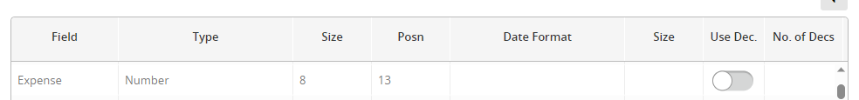
In the Mapping Code field select the option Mapping of Expense Code to Oracle Exps.
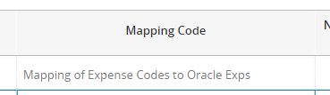

Re-run the GL
If you have mapped a PeopleXD numeric Expense Code to an FMS alphanumeric Expense Code you could re-run the GL to review the output.
Navigate via Payroll Dashboard > select Pay Group > Outputs > General ledger
The General Ledger screen will open:
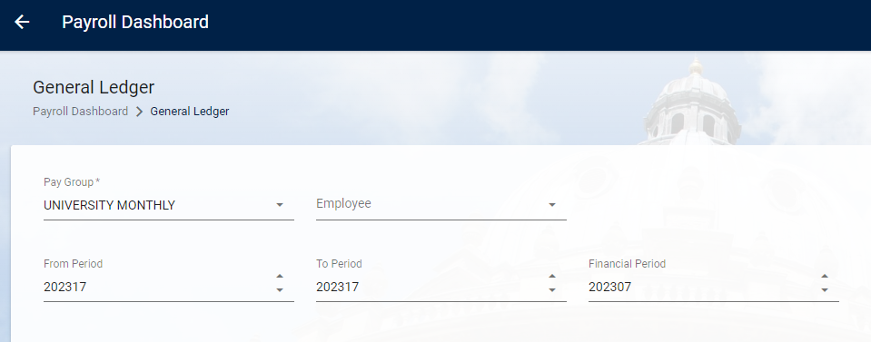
Click Generate

